Enterprise-Multi-Layer-Scheduling-System Installation Guide

- Prerequisites
Before installing and running the system, ensure the following tools are installed:
- Node.js
- npm
- PostgreSQL
- Git
- Prisma CLI

- Clone the Repository
- git clone https://github.com/12Walid-cmd/Enterprise-Multi-Layer-Scheduling-System.git
- cd Enterprise-Multi-Layer-Scheduling-System

- Backend Installation
- cd scheduler-backend
- npm install
- Set it in the .env file under scheduler-backend:
DATABASE_URL="postgresql://<username>:<password>@localhost:5432/<database>"
JWT_ACCESS_SECRET="<your-secret>"
For example:
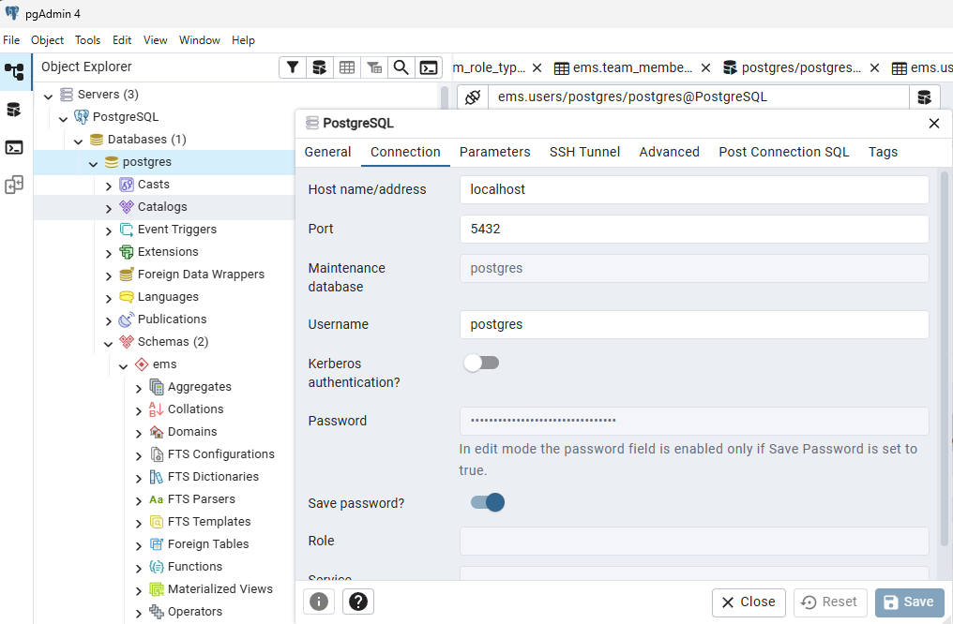
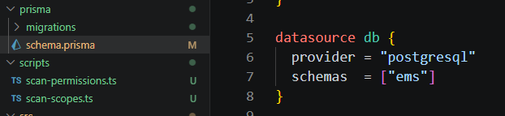
- npx prisma migrate dev
This will create all required tables in your PostgreSQL database.
- npx prisma generate
- npm run start:dev
Backend will run at: http://localhost:3000
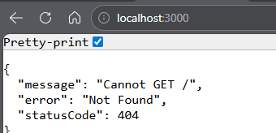

- Frontend Installation
- cd scheduler-frontend
- npm install
- npm run dev
Frontend will run at: http://localhost:5173
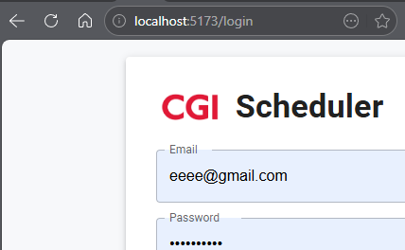

- Project Structure Overview
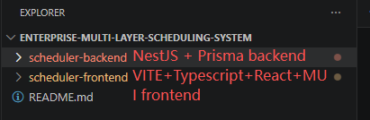

- Common Issues & Fixes
Prisma migration errors:
npx prisma migrate reset
Database connection failed:
Check .env → DATABASE_URL format.

- Running Both Services Together
Open two terminals:
Terminal 1 — Backend
cd scheduler-backend
npm run start:dev
Terminal 2 — Frontend
cd scheduler-frontend
npm run dev

